Catcher tool user guide
- Before using the Catcher, you should connect the usb port to the PC correctly.
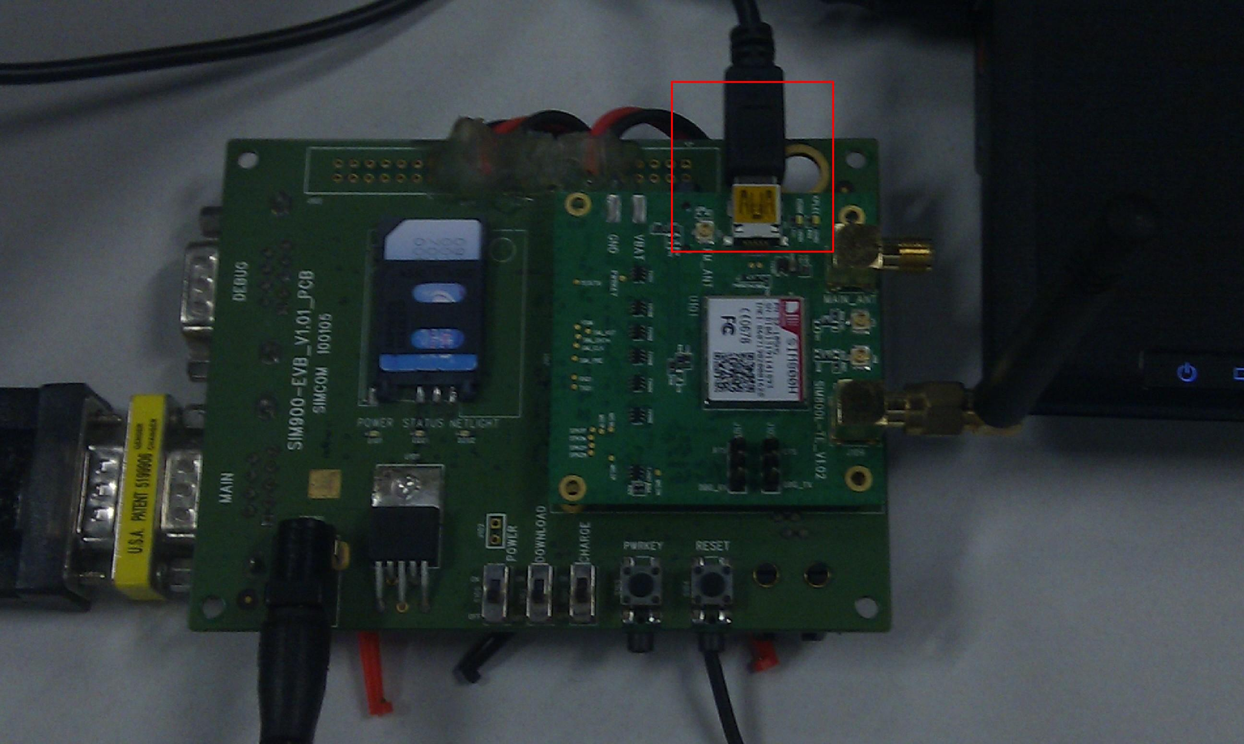
- Setup the USB driver: MTK_USB_DRIVER.


2. click the file Catcher_exe_v3.1228.00.rar to expand it. Start the tool “Catcher”:

You can see the interface as blow:
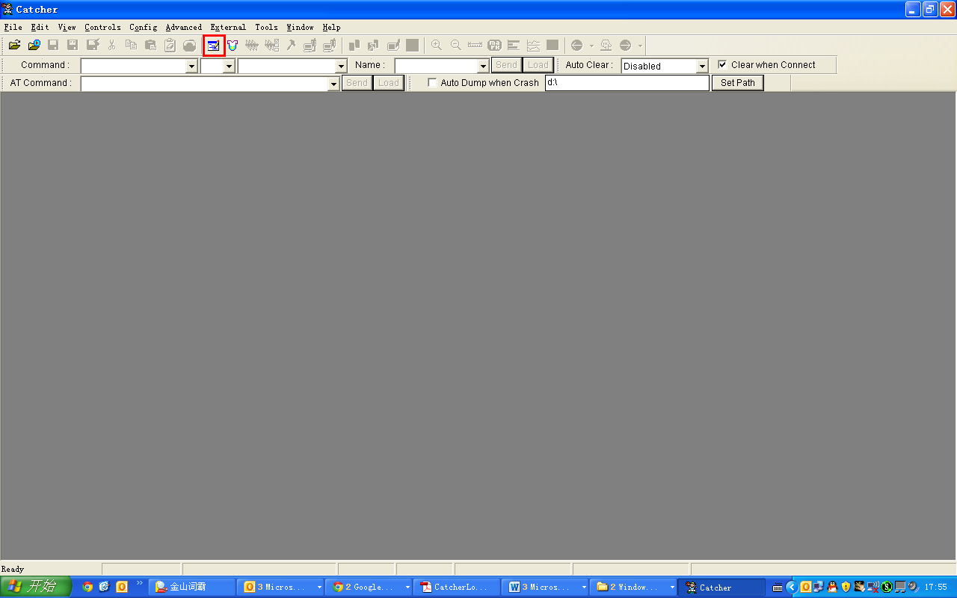
3 Click the icon “logging mode”,as the above figure:
4 click “config”-“Set the Database Path” then you will see the illustrate as below figure,then set the database file
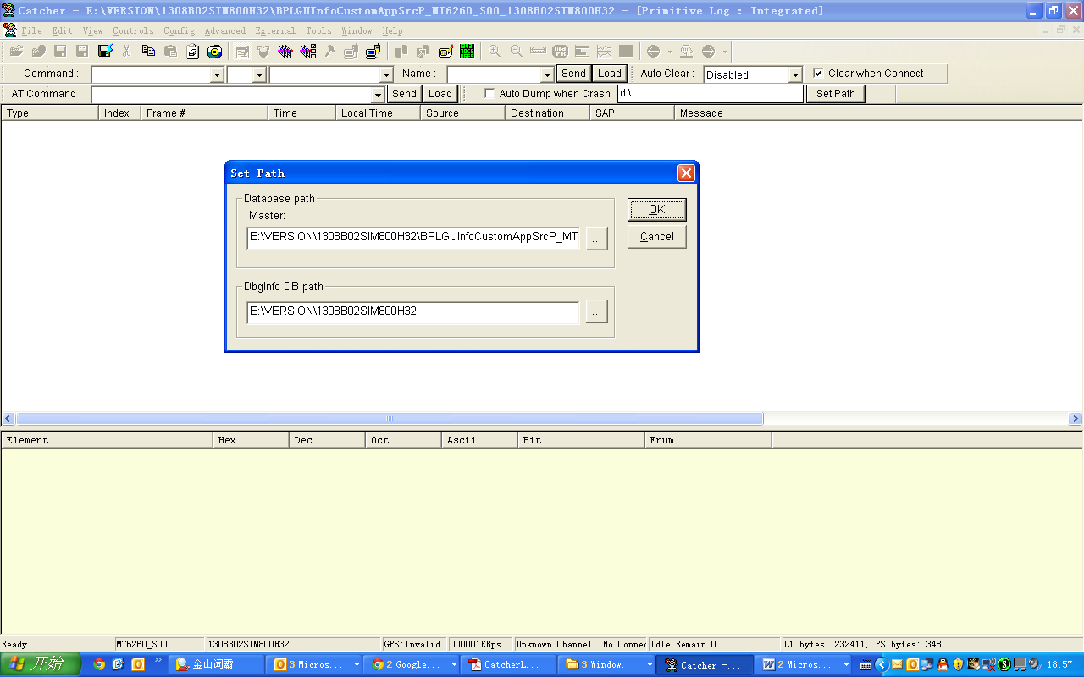
Note: in this example ,the Database file:
(BPLGUInfoCustomAppSrcP_MT6260_S00_1308B02SIM800H32) is in the folder: 1308B02SIM800H32.
5 Click the icon , then set the port and baud rate.
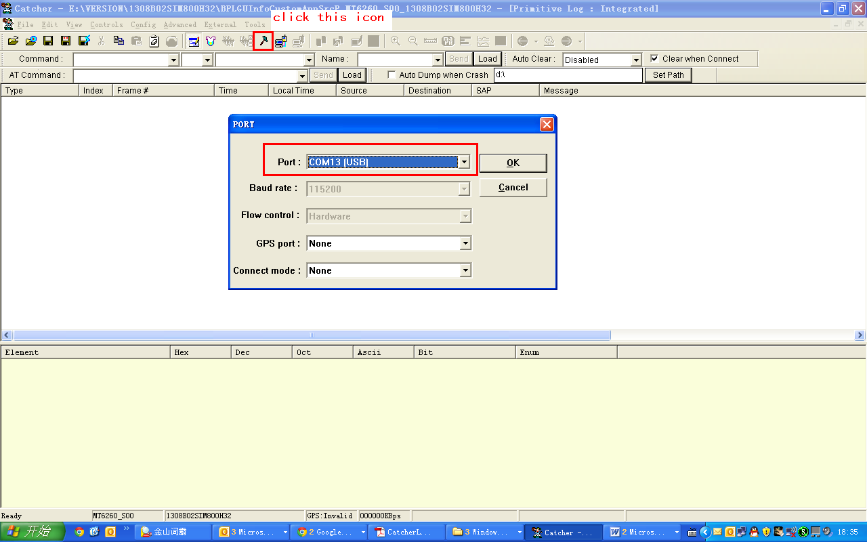
Please note : the port should select according to your computer’s “Task mange “(COM and LPT) as below: in this example ,the port should select USB PORT COM13
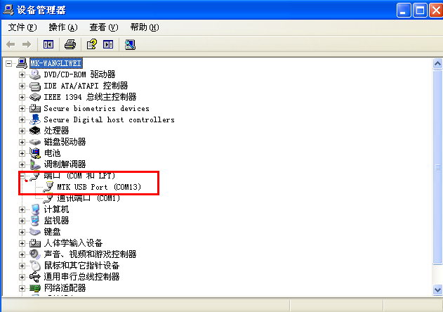
5 click the icon “connect“ as below
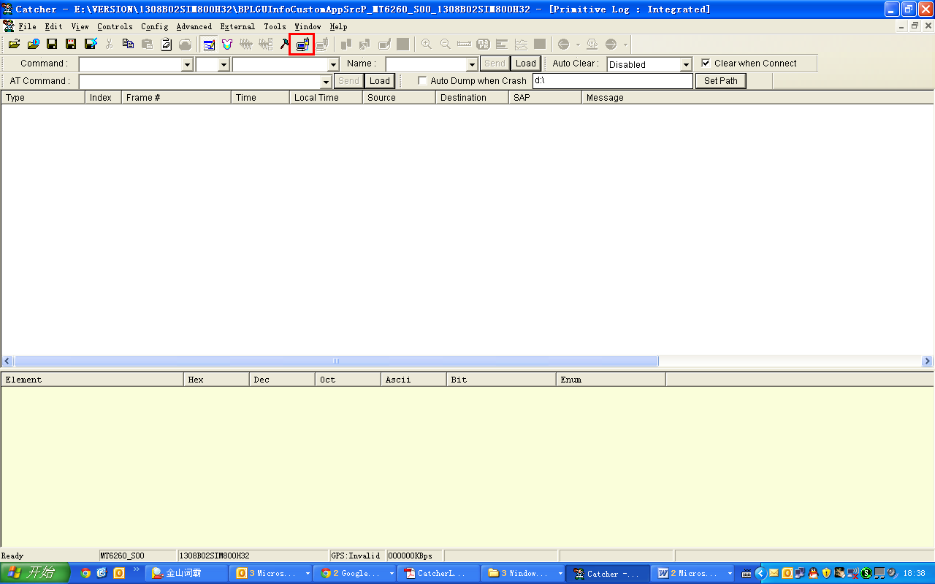
6 Click the icon “Filter”, you will see the “Filter box “ as below figure: please choose the options according to the requirement of trace.
In this example, we choose three options: 1 MOD_CSM, only tick “MOD_CSM”. 2 MOD_L2SP , tick “MOD_L1SP” then click right button ,select “all class on ”. 3 MOD_MED , only tick “MOD_MED”.
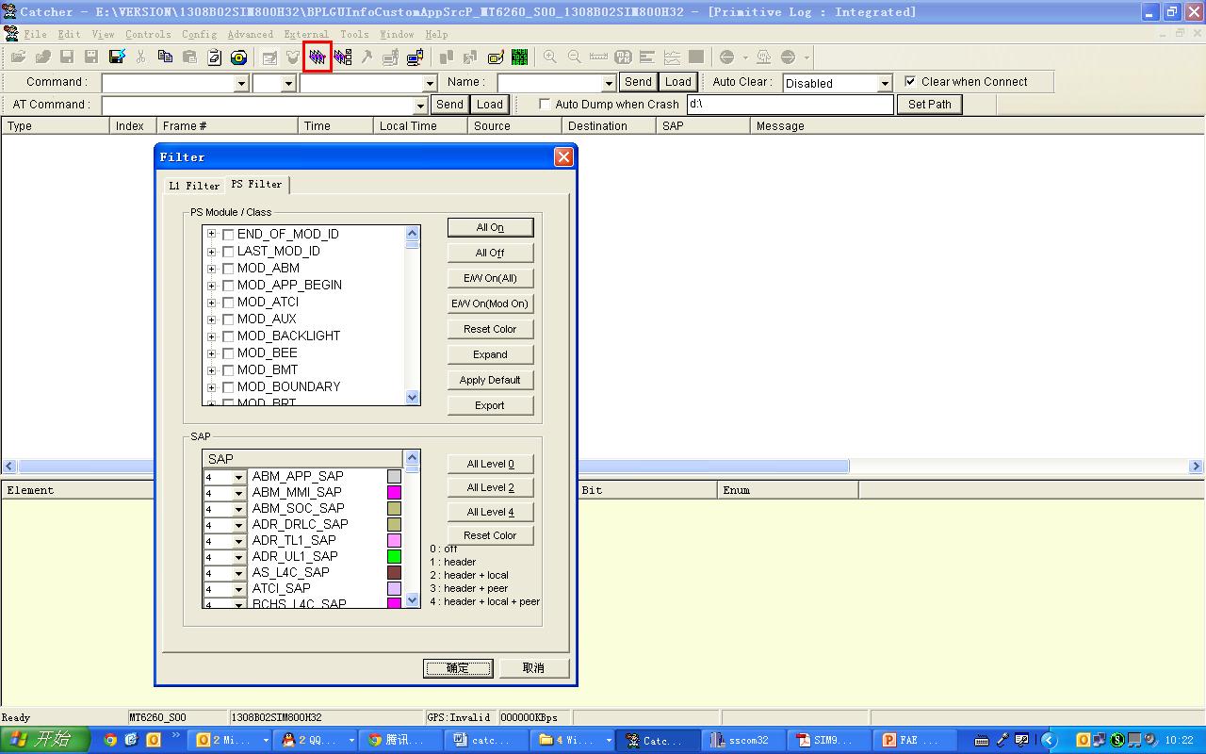
7 Click the option “view” , select “view ”---“PS Integrated” as below
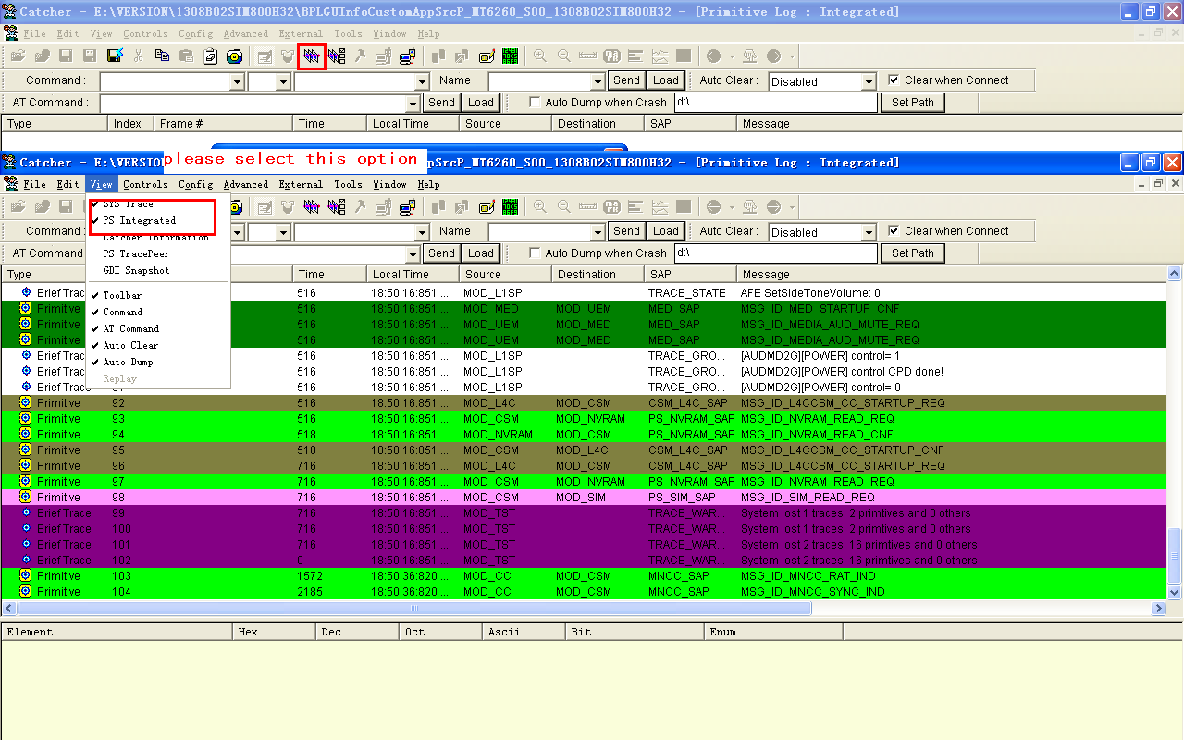
Now you will see the trace log.
8 you could connect the module “MAIN PORT” to computer by series line. Send the AT command to the module. When you do the test, the tool catcher will take note the log .
When you finish testing, please click “file ”—“save log”, then send the log text to us for analyzing .

